18} 2

Write down Linux commands for following statements: select the lines in a file which has 4 letter words in that line and redirect the output to the file named list.show with example

grep -w '\b\w\{4\}\b' input_file.txt > list

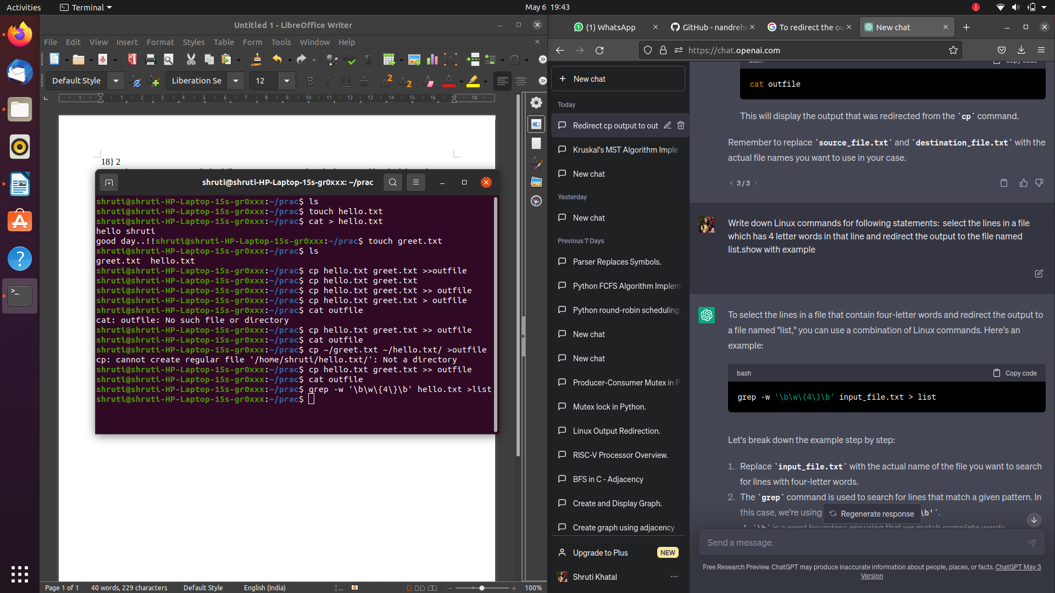

Replace input_file.txt with the actual name of the file you want to search for lines with four-letter words.

1. The grep command is used to search for lines that match a given pattern. In this case, we're using the pattern '\b\w\{4\}\b'.
   * \b is a word boundary, ensuring that we match complete words.
   * \w represents a word character.
   * \{4\} specifies that we're looking for exactly four occurrences of the previous pattern (four-letter words).
2. The -w option in grep ensures that it matches complete words only, avoiding partial matches.
3. The output of the grep command is then redirected to the file named "list" using the > symbol.

After running the command, the lines in the input file that contain four-letter words will be stored in the "list" file.

3}

Write down Linux commands for following statements: Assign write permission to owner and remove read permissionfromgroup user for an ordinary file named test by relative way show with example

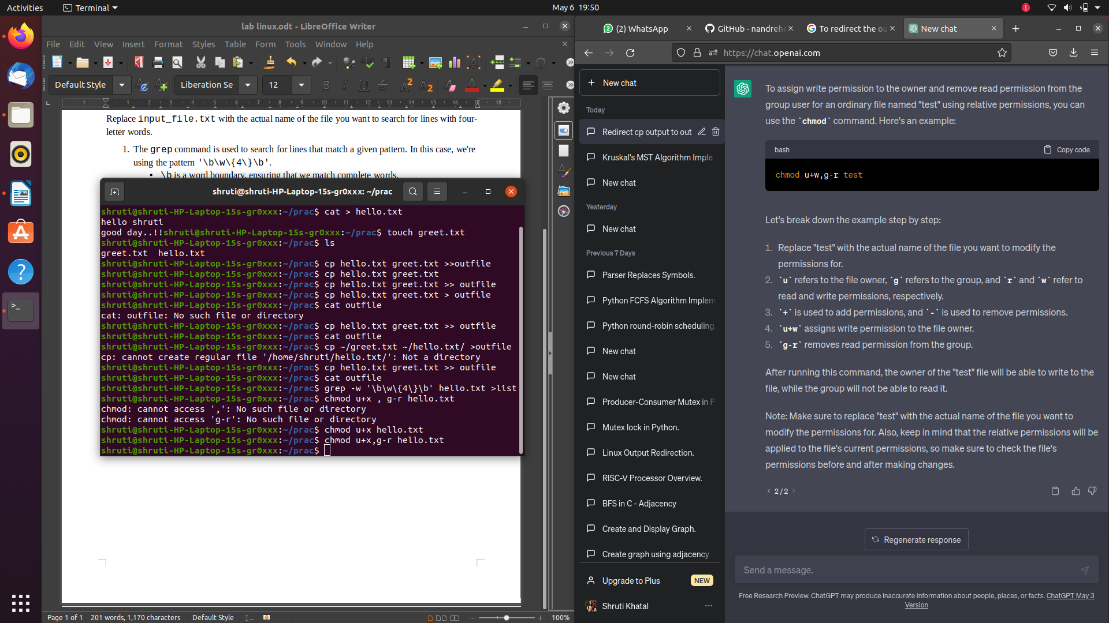

Replace "test" with the actual name of the file you want to modify the permissions for.

1. u refers to the file owner, g refers to the group, and r and w refer to read and write permissions, respectively.
2. + is used to add permissions, and - is used to remove permissions.
3. u+w assigns write permission to the file owner.
4. g-r removes read permission from the group.

4}

Create an alias named ls that always lists all the files including hiddenfiles. show with example.

Open your shell configuration file using a text editor. For example:

nano ~/.bashrc

Add the following line at the end of the file:

alias ls='ls -al'

This line defines an alias named ls and sets it to execute ls -al.

* The -a option lists all files, including hidden files.
* The -l option provides detailed information about each file.
* Save the file and exit the text editor.
* To make the changes take effect, either restart your terminal or run the following command to reload the shell configuration file:

source ~/.bashrc

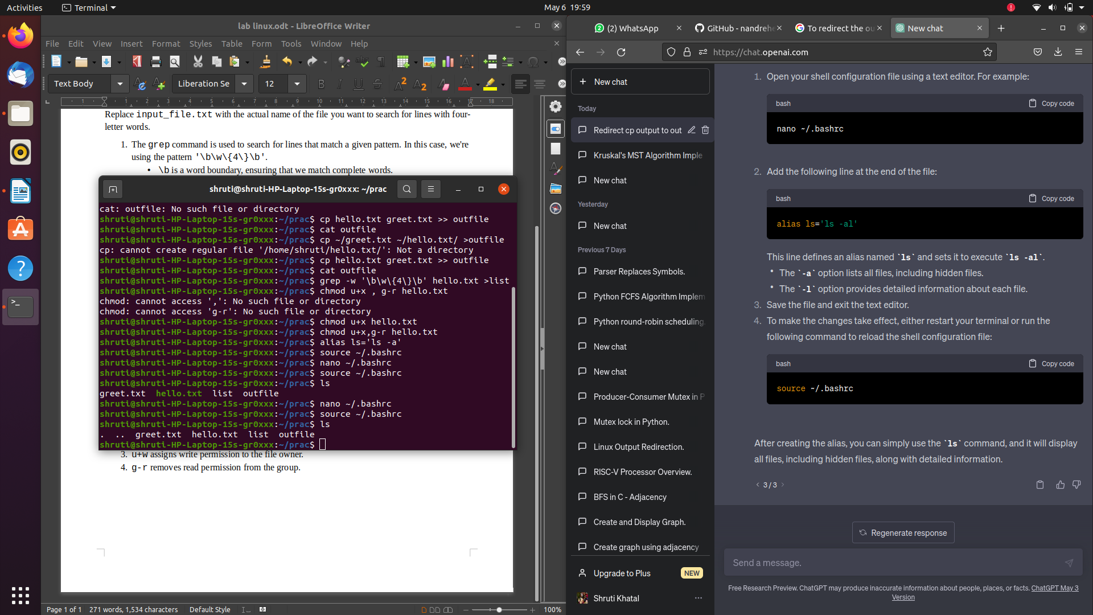

5} Count the number of words in the list file.

In this example, replace "list" with the actual name of your file.

The wc command is used to display counts of lines, words, and characters in a file. The -w option specifically counts the number of words in the given file.

After running the command, the output will display the number of words in the "list" file.

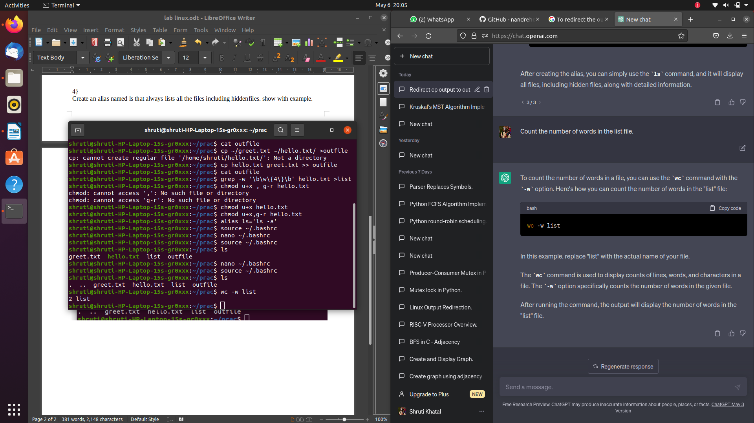

19}

1}Write down Linux commands for following statements: a. Redirect the output of mv command to a file named outfile. Use this as an input file for remaining commands.

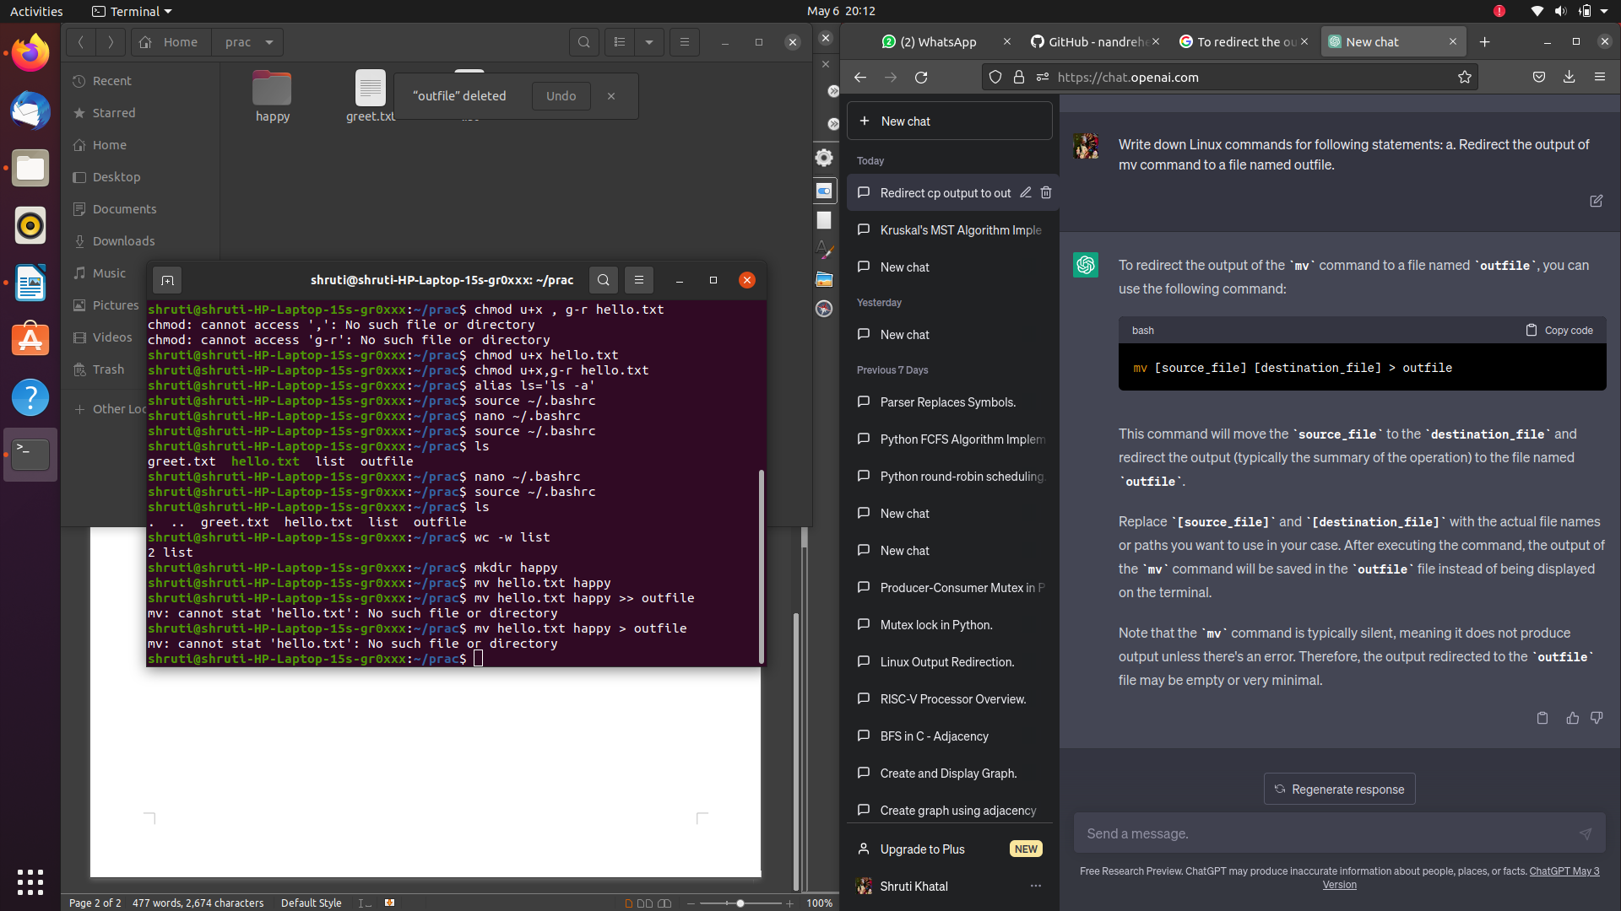

2}List all hidden files under current directory and store in “hidden”file show with example

ls -a lists all files and directories, including hidden ones. The -a option enables the display of hidden files (those starting with a dot).

1. The output of ls -a is piped (|) to the grep command.
2. grep "^\." filters the output of ls -a to only show lines starting with a dot, which indicates hidden files.
   * "^\." is a regular expression that matches lines starting with a dot.
3. The > symbol is used to redirect the output of the previous command to a file named "hidden". It creates the file if it doesn't exist or overwrites it if it does.
4. After running the command, the hidden files will be listed in the terminal, and the same list will be stored in the "hidden" file.

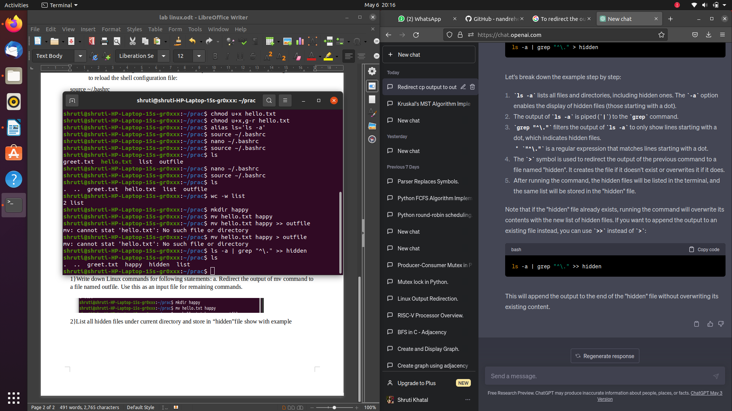

3}Assign write permission to group user and remove execute permission from owner for an ordinary file named test by absolute way

chmod 640 test

6 represents the owner's permissions, 4 represents the group's permissions, and 0 represents the permissions for others (everyone else).

* The first digit, 6, sets the owner's permissions. In this case, it sets read and write permissions (4 for read, 2 for write, and 1 for execute), so the owner will have read and write permissions.
* The second digit, 4, sets the group's permissions. In this case, it sets read permissions only, so the group will have read permissions.
* The third digit, 0, sets the permissions for others. In this case, it sets no permissions (no read, write, or execute permissions) for others.
* After running the command, the owner of the "test" file will have read and write permissions, the group will have read permissions, and others will have no permissions.

4}To create soft and hard link for given file

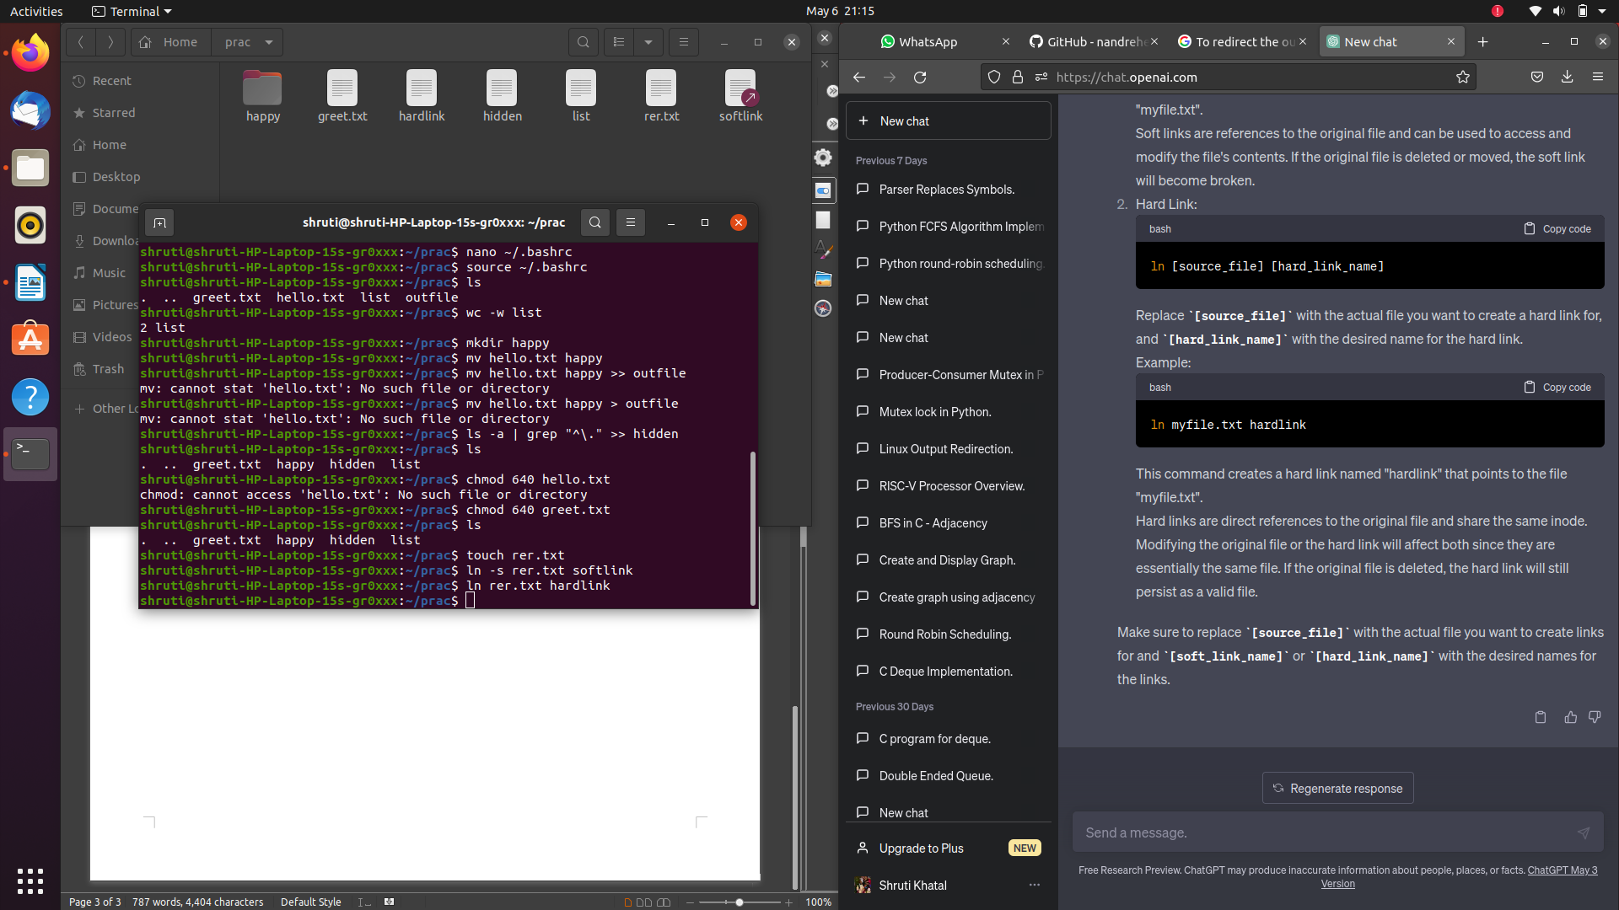

This command creates a symbolic link named "softlink" that points to the file "myfile.txt".

Soft links are references to the original file and can be used to access and modify the file's contents. If the original file is deleted or moved, the soft link will become broken.

Hard links are direct references to the original file and share the same inode. Modifying the original file or the hard link will affect both since they are essentially the same file. If the original file is deleted, the hard link will still persist as a valid file.

5}To convert lowercase to upper case of a given file with example.

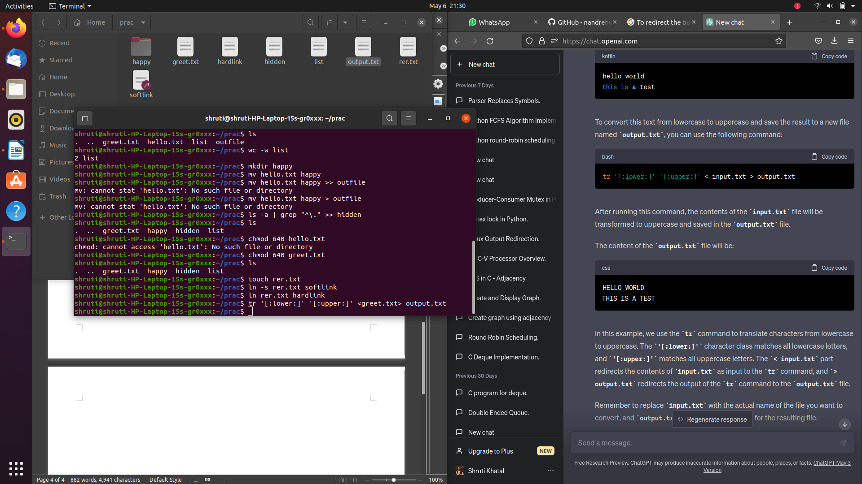6} To extract 2nd and 3rd character of a given file

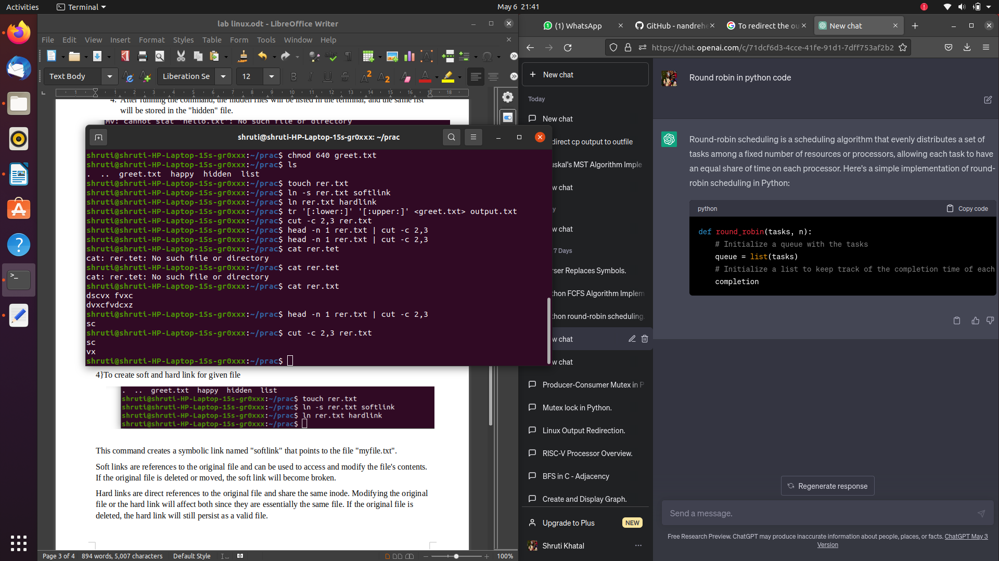7}To display how many times lines are repeated in a given file show with example linux commands

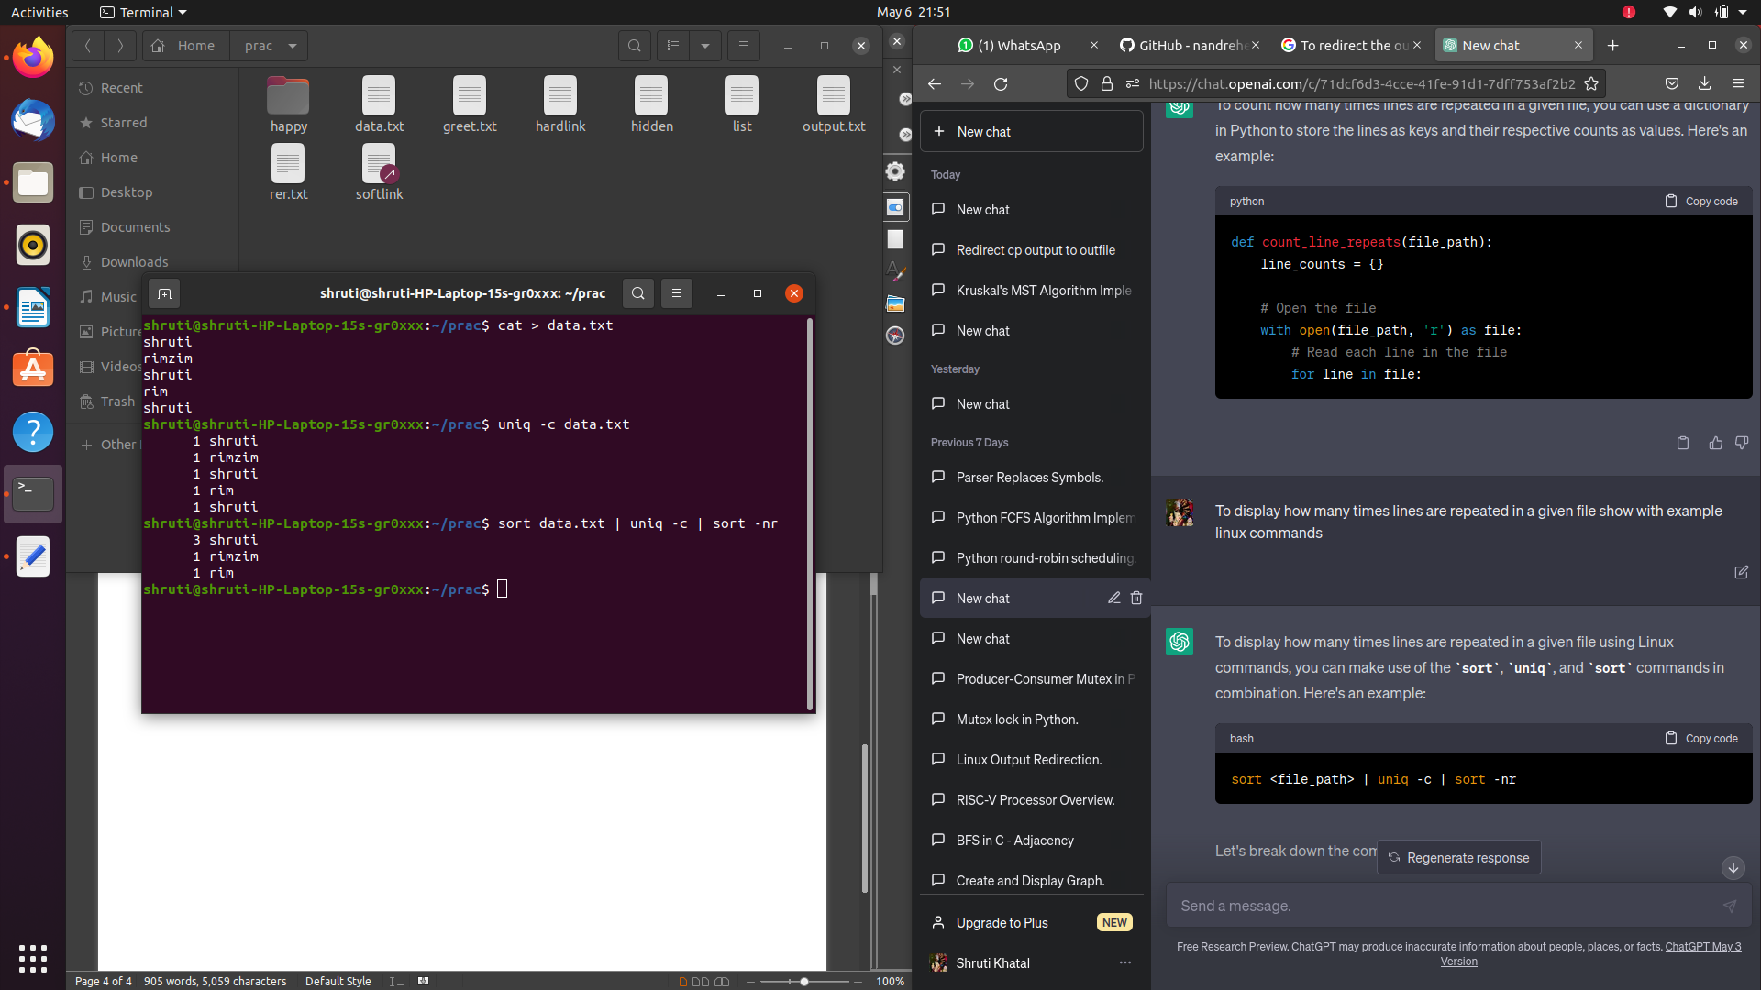**2]**

1} Write down Linux commands for following statements: i. Redirect the output of ls command to a file named outfile. Use this asaninput file for remaining commands.

ls > outfile

2 }To select the lines in a file which has digit as one of the character inthatline and redirect the output to the file named list.

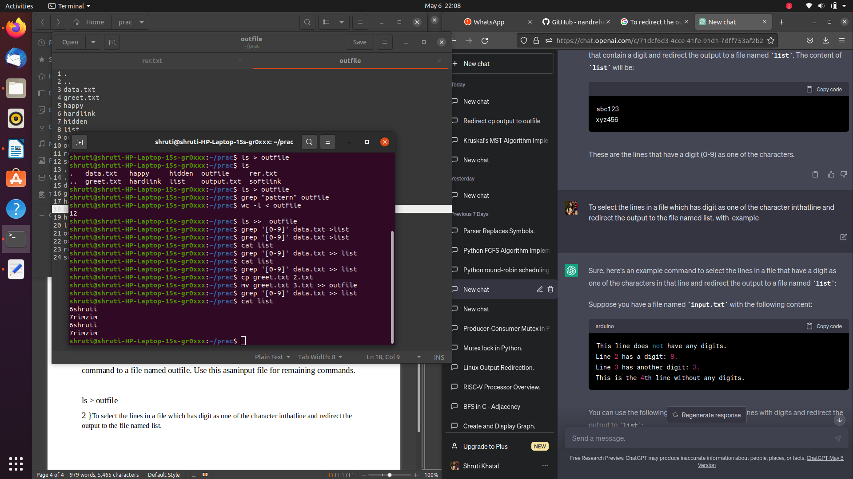3} Assign execute permission to owner and remove read permissionfromother for an ordinary file named test by relative way.

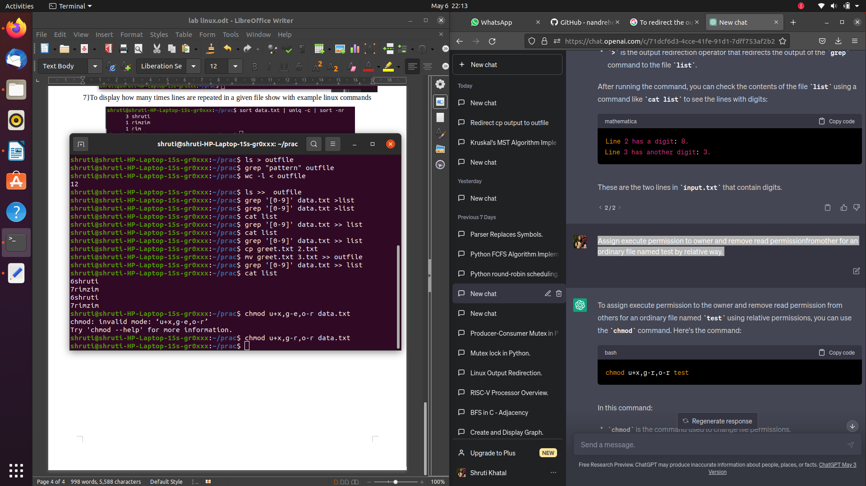4}Create an alias named rm that always deletes file interactively.

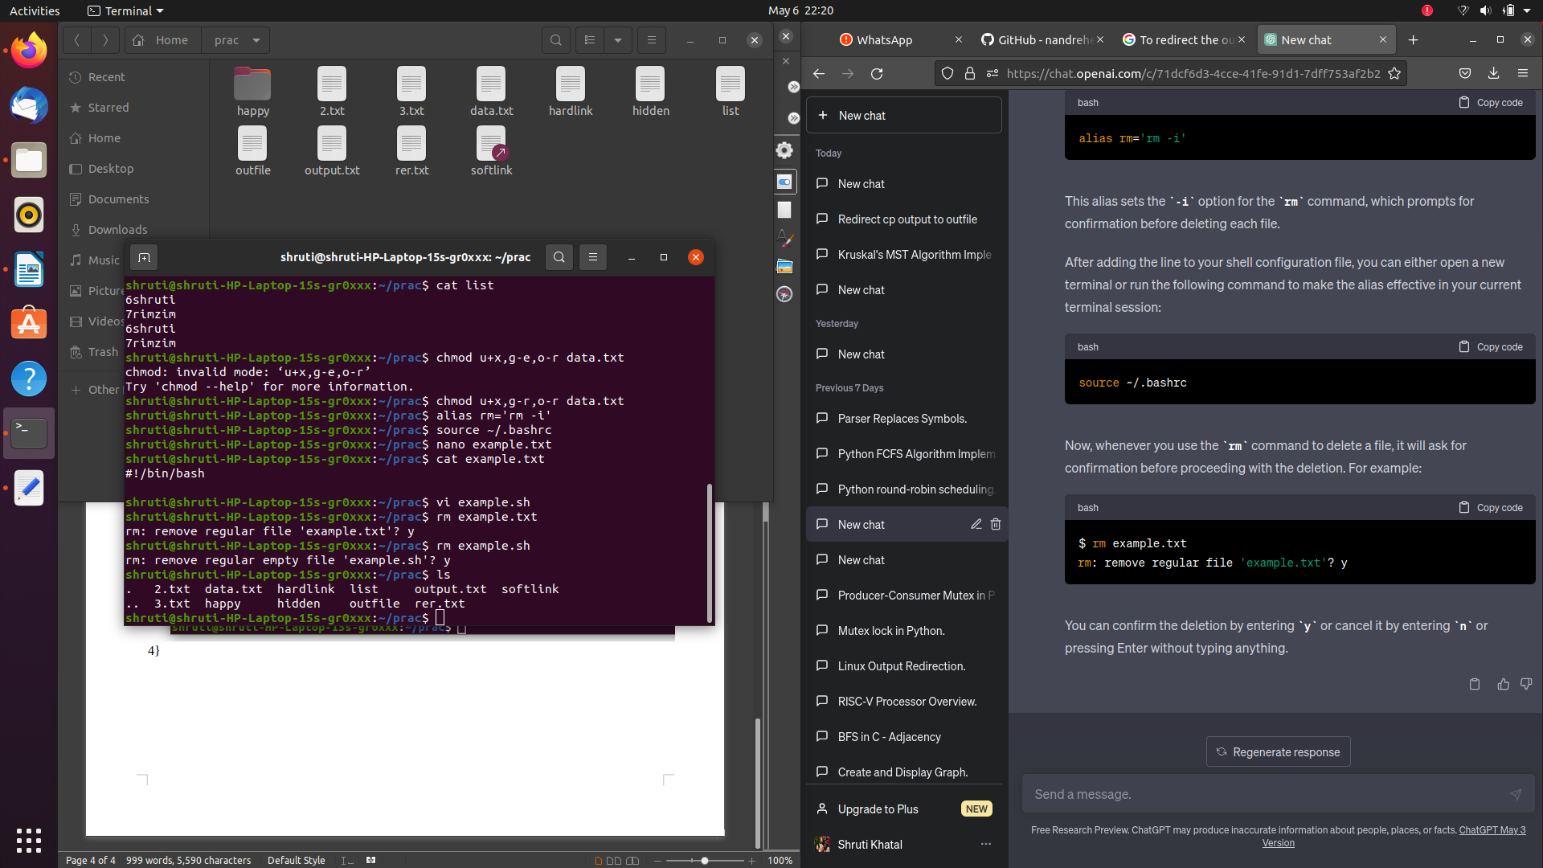

5 } Count the currently login users to the system.

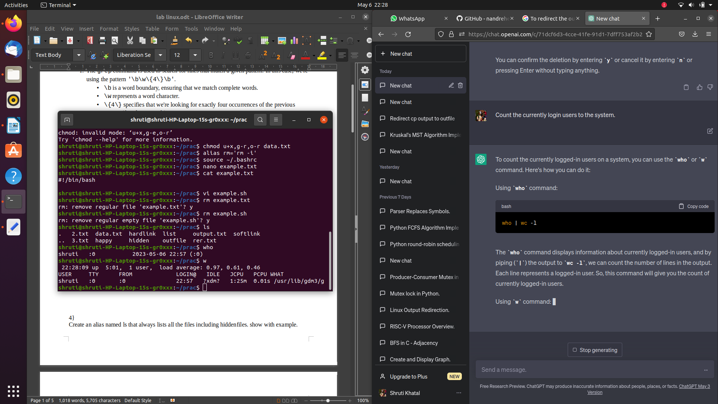{3}

1}Redirect the output of cat command to a file named outfile.

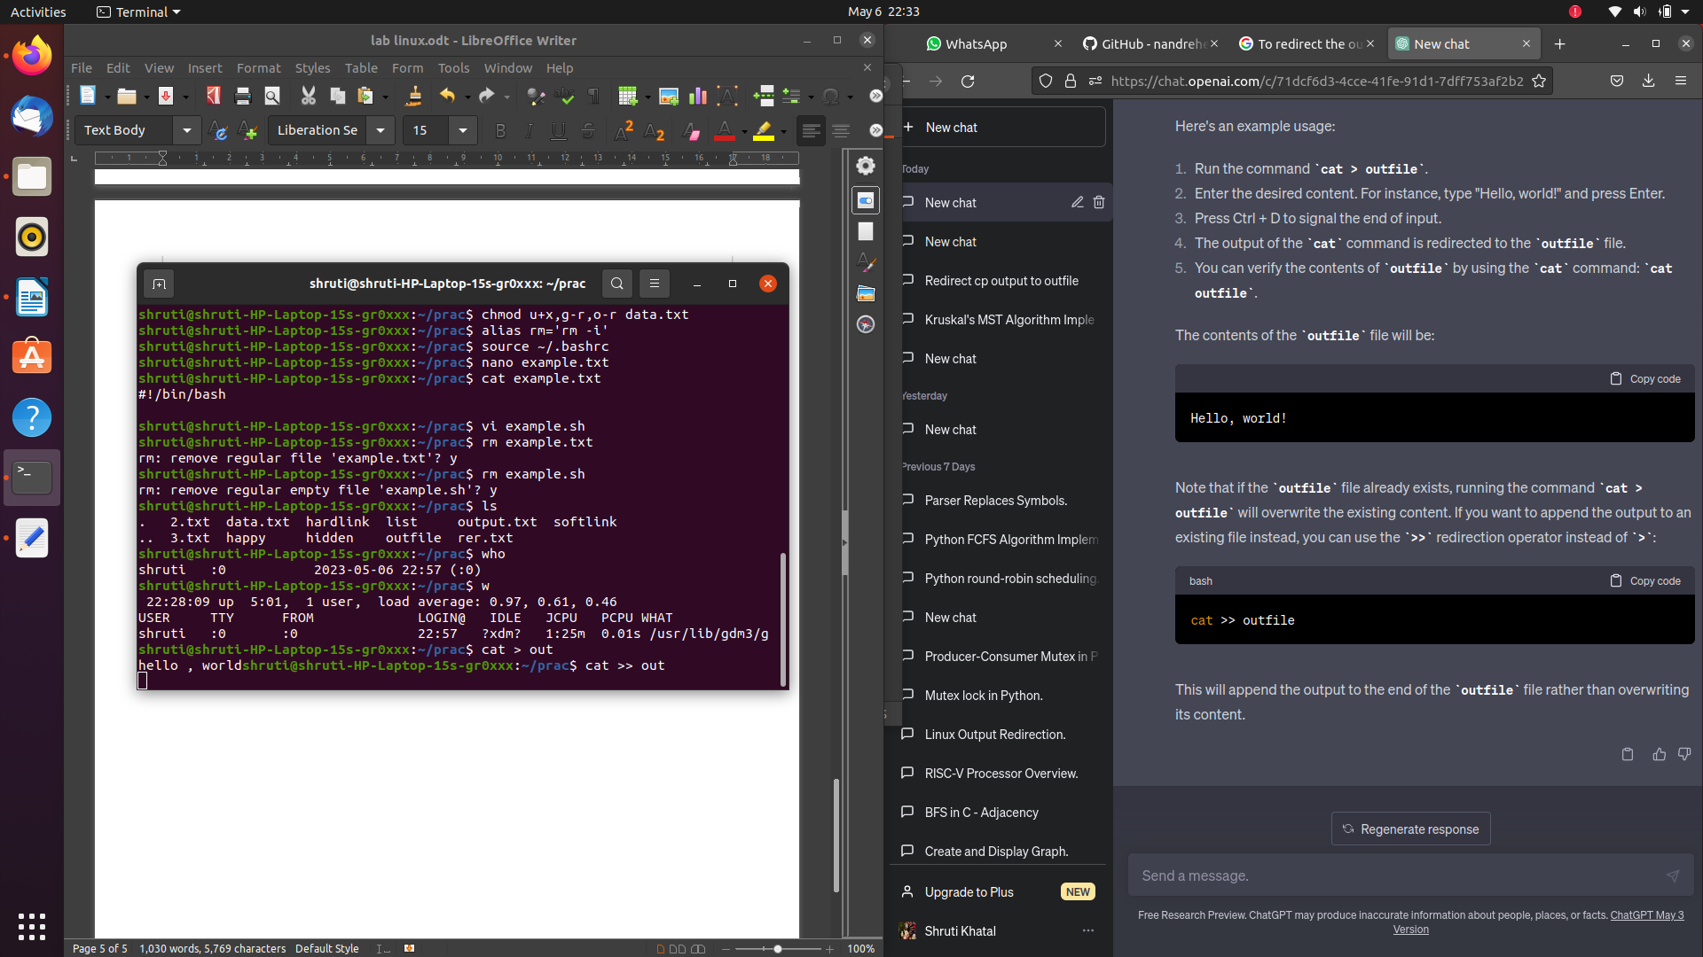

2}List all hidden files under current directory and store in “hidden” file

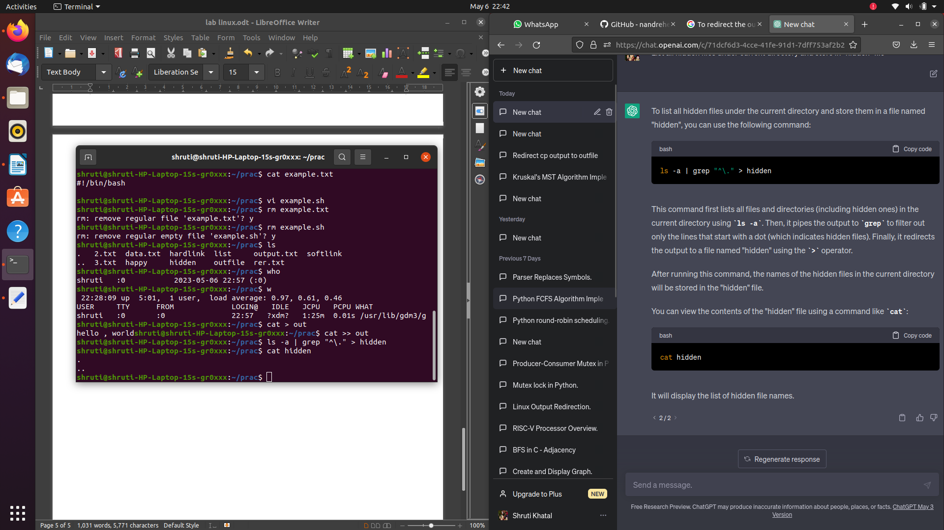3}Assign write permission to owner and remove execute permissionfromother for an ordinary file named test by absolute way.

chmod 600 test

chmod is the command used to change file permissions.

* 600 is the numeric representation of the permissions.
  + The first digit (6) represents the owner's permissions.
  + The second and third digits (0) represent the group's and others' permissions, respectively.
  + In this case, 6 corresponds to read and write permissions for the owner (110 in binary).
  + The 0 corresponds to no permissions for the group and others (000 in binary).
* test is the name of the file for which you want to modify the permissions.

4}to extract 1st and 10th character of a given file

